|  |  |
| --- | --- |
| **“TrendTrails” Online retail APPAREL SHOPPING App**  Shop Top Brands & Looks Fashion App | **Abstract**  This assignment explores a strategic journey for online fashion app TrendTrails, encompassing customer personas, keyword market research, and a robust ASO strategy. Detailed steps include web-based discovery, competitor analysis, timeline monitoring, and ASO recommendations. The document captures a comprehensive approach to enhance TrendTrails' position in the online fashion retail market.  **Group Members**:  Vaishali Balendar (12220015)  Amit Thorat (12220013)  Sambit Patra (12220027)  Arpit Agarwal (12220065)  Dev Vrat Bhatt (12220017)  **AMPBA Batch 19** |

Table of Contents

1. Abstract 2

2. Customer Persona 3

3. Market research on the Keywords 6

4. App Store Optimization Strategy for TrendTrails 11

4.1. Web-based Discovery: Top 10 keywords 11

4.2. Competitors Identified with the keyword - Fashion. 13

4.3. Competitors Timeline Monitoring 17

4.4. Competitors progress Monitoring and Updates 21

4.5. Competitors Paid Keyword Search Analysis 22

5. ASO Based App Recommendation 27

## Abstract

In this comprehensive assignment, we meticulously navigated through the multifaceted realm of online fashion apparel retail shopping app analysis and App Store Optimization (ASO) optimization. Our journey began with the establishment of customer personas, followed by an exhaustive market research initiative to identify, and strategically employ top keywords.

The ASO strategy for TrendTrails unfolded with a web-based discovery approach, unraveling the top 10 keywords critical for optimal visibility. A profound analysis of competitors, specifically identified through the keyword 'Fashion,' offered valuable insights into their timeline, progress monitoring, and updates. The intricate examination extended to a detailed investigation of competitors' paid keyword search strategies.

Further enriching the assignment, we incorporated SEO-based app recommendations to enhance TrendTrails' overall digital presence. This document encapsulates the meticulous execution of each step, as outlined in the table of contents, providing a holistic view of our efforts to position TrendTrails as a formidable player in the competitive landscape of online fashion retail.

## Customer Persona

Considering comprehensive secondary research and the assignment's objectives, three distinct personas have been meticulously identified to strategically tailor our app's user targeting. These personas are strategically chosen to maximize impact and resonance:

* Ms. Shreya Pilgaonkar: A vibrant young professional living the bachelorette life in bustling urban areas, embodying the spirit of contemporary urban living.
* Mrs. Riya Sharma: An aspirational professional, married with two children, navigating the challenges of a dynamic urban lifestyle while pursuing personal and career growth.
* Rohan Kumar: A young graduate from a tier 2 city, recently stepping into the corporate world within the technology sector, representing the aspirations and ambitions of the next generation.

This targeted approach ensures a nuanced and effective digital marketing strategy, catering specifically to the unique needs and lifestyles of these carefully identified personas.

**Ms. Shreya Pilgaonkar**

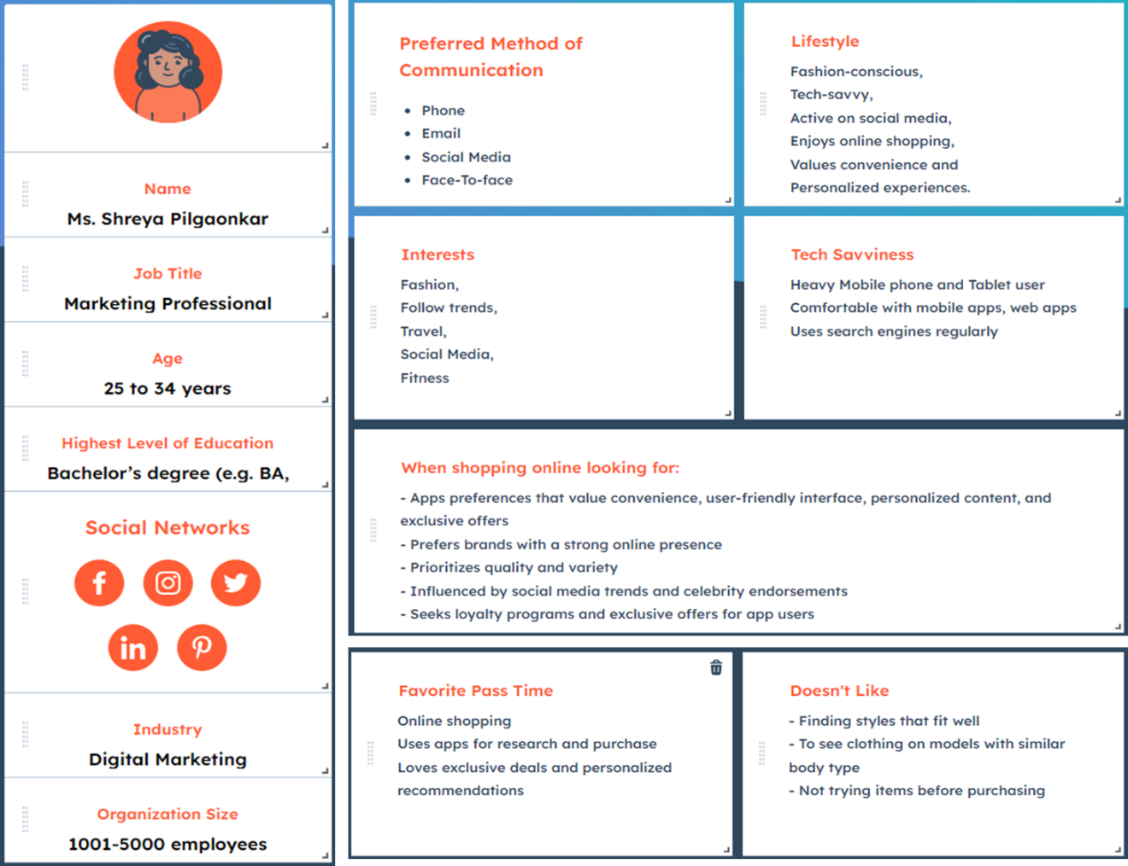

**Mrs. Riya Sharma**

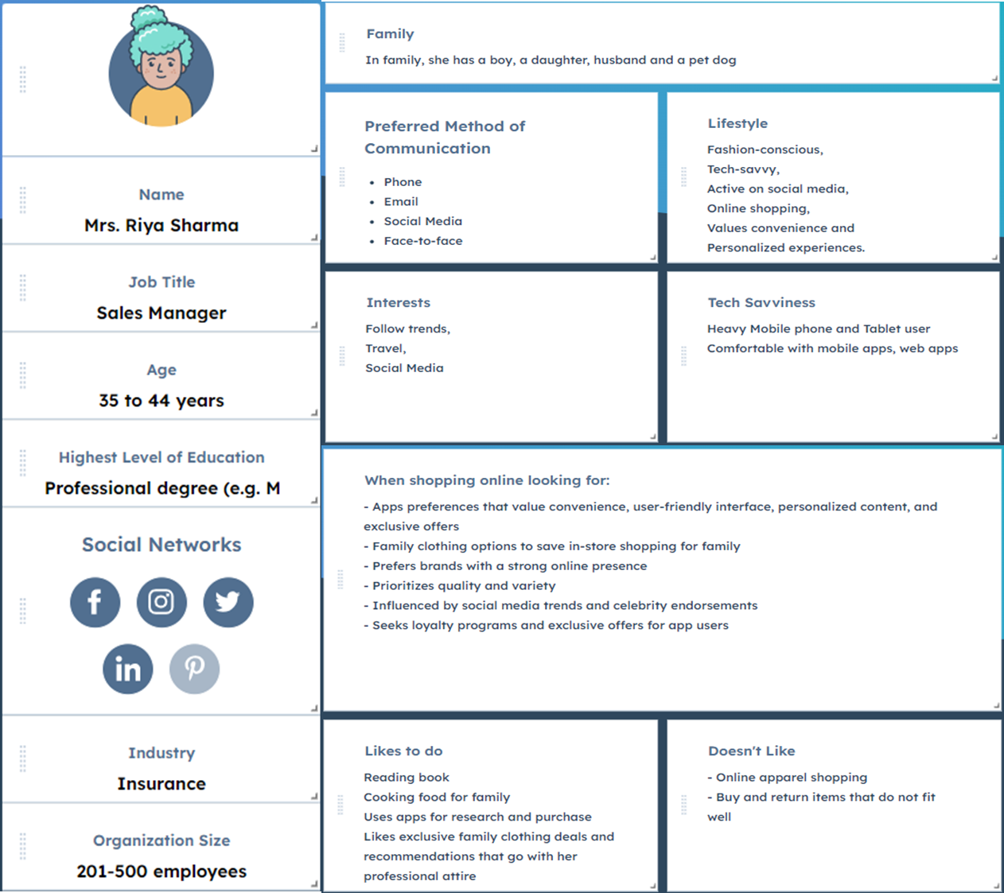

Rohan Kumar

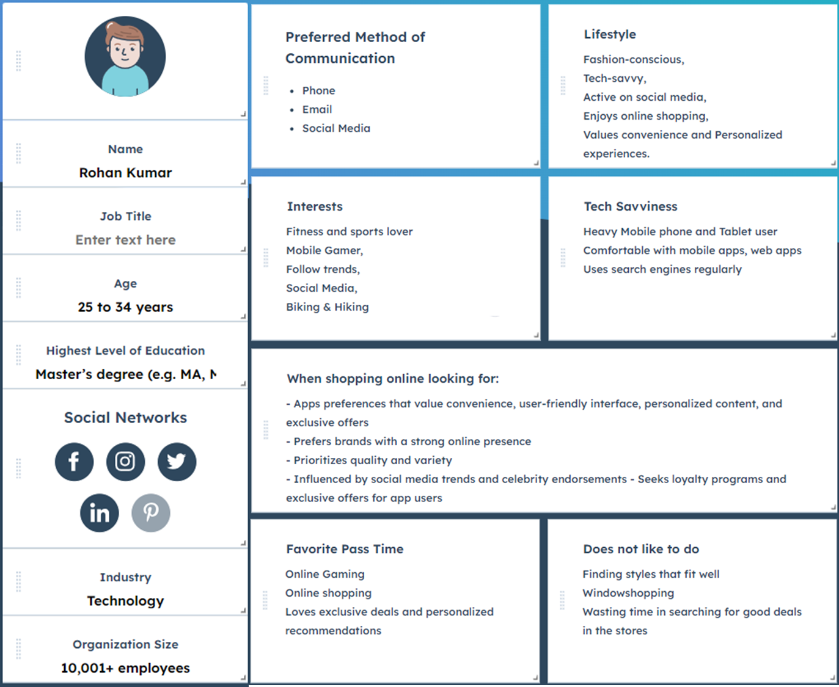

## Market research on the Keywords

Upon conducting a search using the keyword "Fashion," a discerning analysis revealed the identification of numerous keywords intricately linked to the realm of fashion. This insightful exploration not only broadens the scope but also presents a comprehensive understanding of the interconnected landscape of fashion-related keywords.

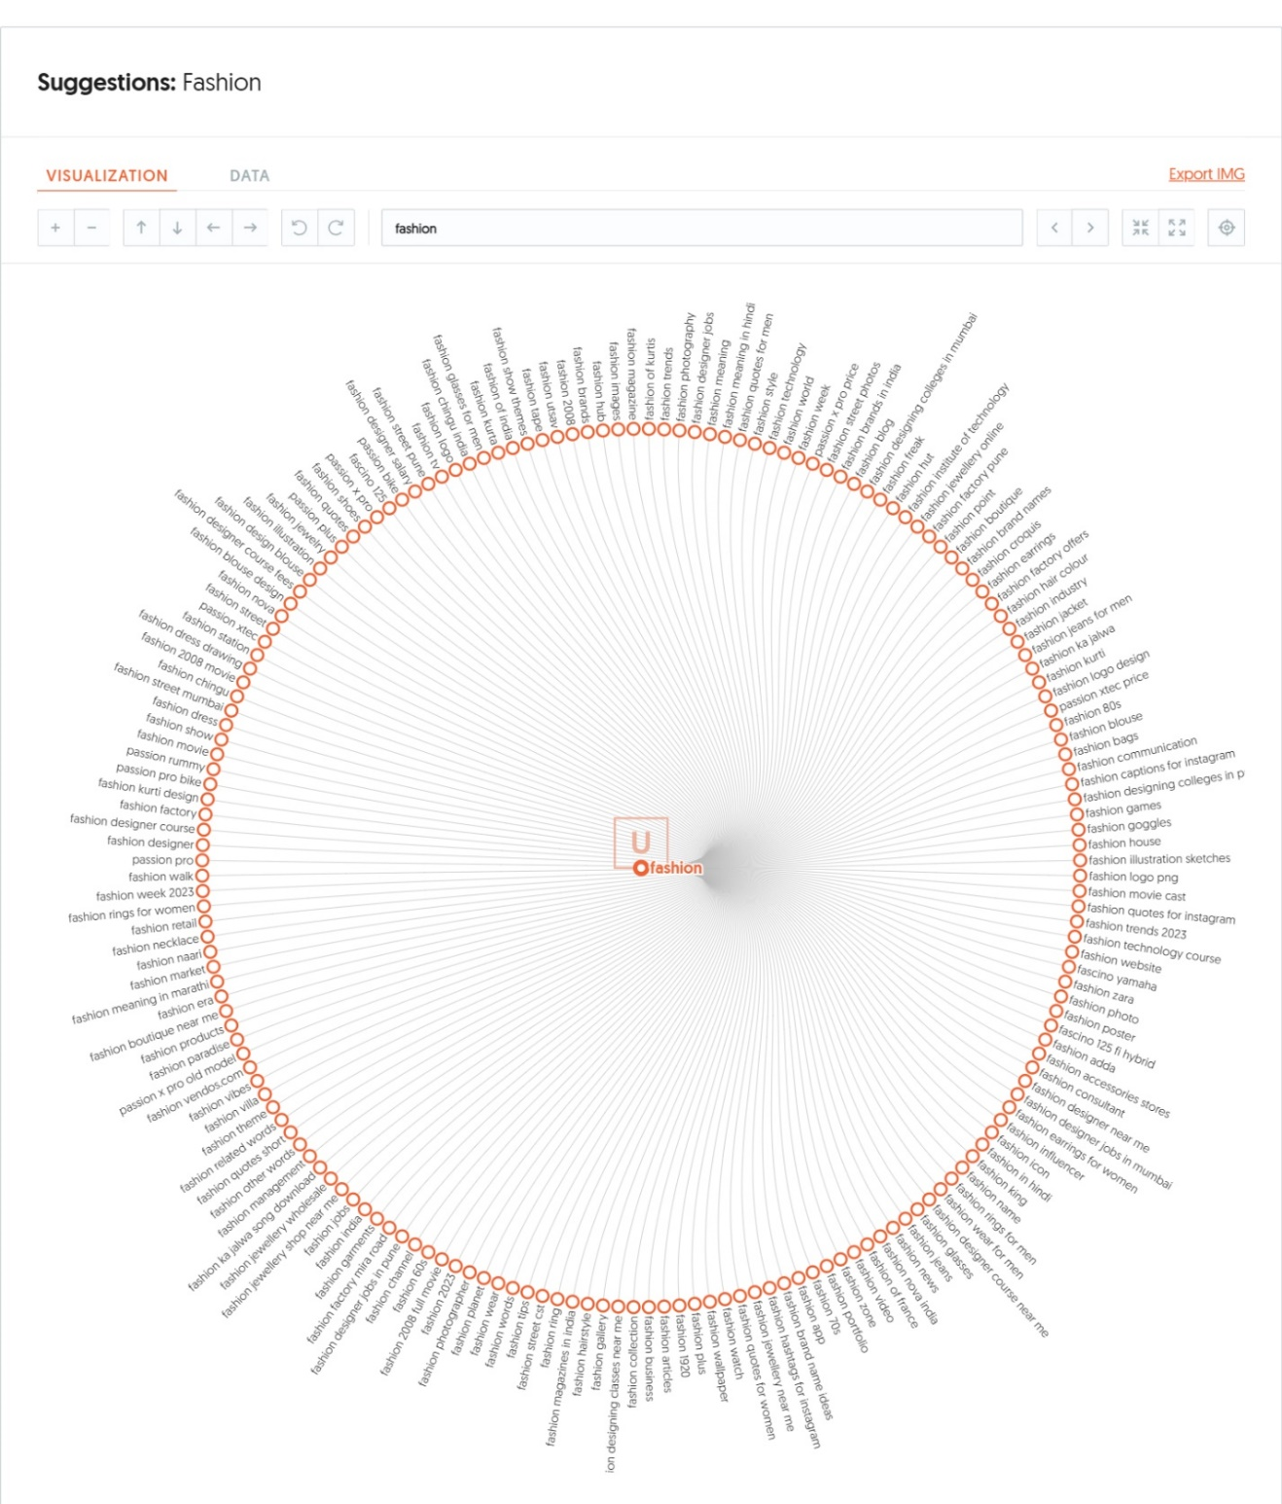

Efficiently discern and evaluate derived keywords stemming from the primary keyword 'Fashion,' measured across four key metrics: volume, cost per click (CPC), paid difficulty, and SEO difficulty. This meticulous analysis provides a holistic understanding, enabling strategic decision-making in our marketing endeavors.

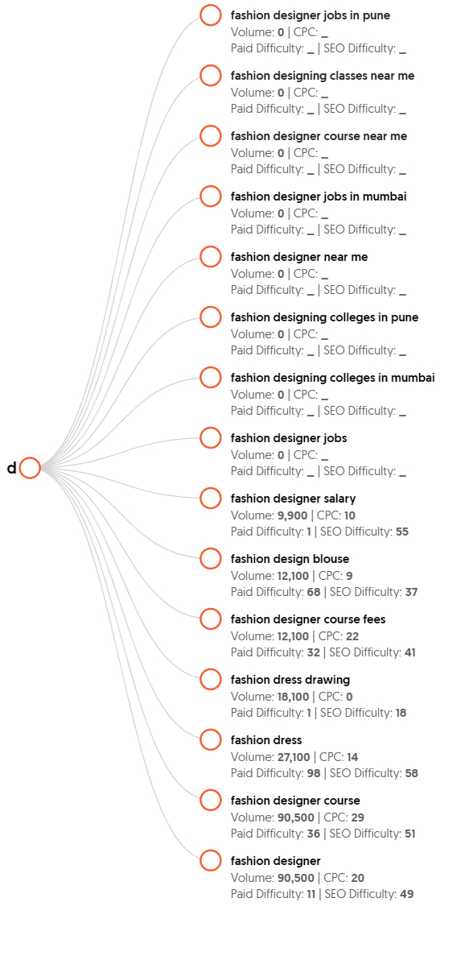

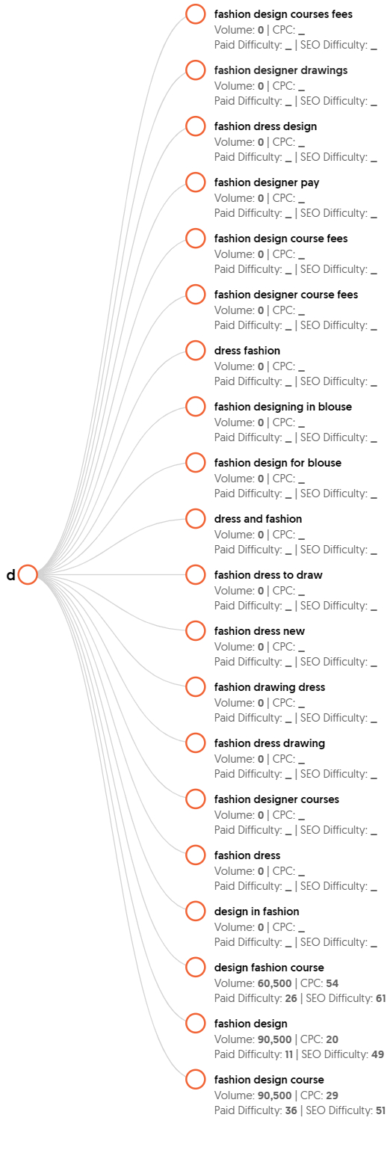

More variations can be analyzed from the website:

<https://app.neilpatel.com/en/ubersuggest/keyword_visualization?keyword=fashion&lang=en&locId=2356&mode=keyword>

Similarly looked at the **‘trend’** as keyword. Able to identify multiple keywords that are related to Fashion keywords**.**

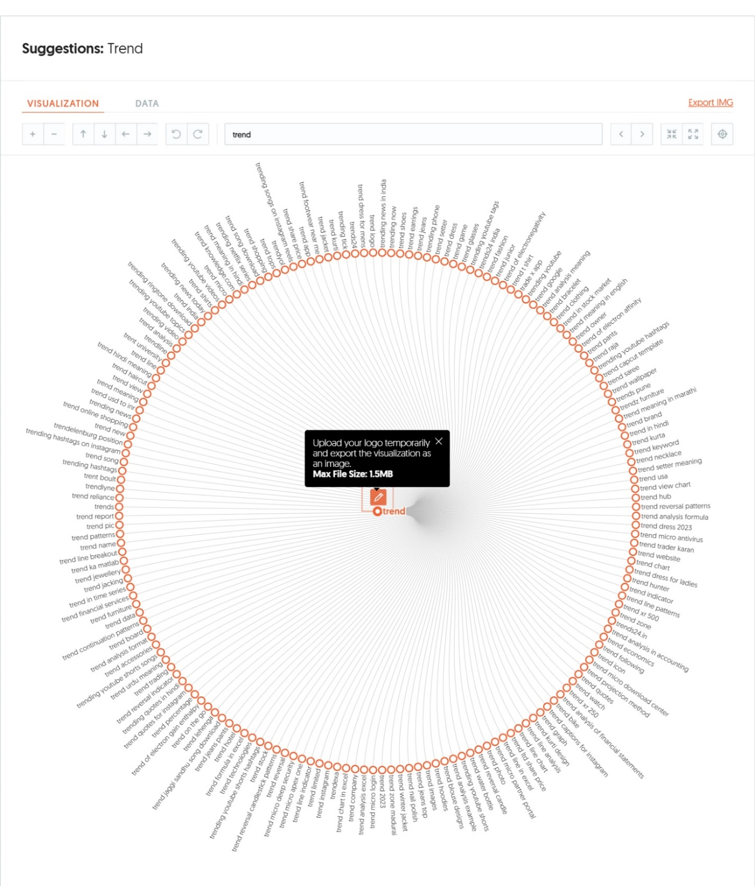

Identify the derived keywords from the main keyword ‘Fashion’ measured across four metrices – volume, cost per click (CPC), paid difficulty and SEO difficulty.

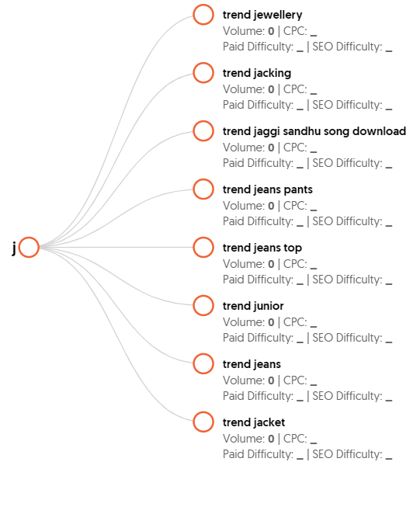

**Note:** for all the derived keywords the metric data is not available either due to free version of the software is being used or information is not available in the website.

## App Store Optimization Strategy for TrendTrails

To enhance the visibility of the TrendTrails App on the Android platform, a strategic five-phase approach has been devised. This method delves into identifying optimal keywords that can propel TrendTrails ahead of its competition in the Indian online fashion apparel market. The competitive landscape includes five major players:

1. Myntra - Fashion Shopping App
2. AJIO Online Shopping App
3. LimeRoad: Online Fashion Shop
4. Nykaa Fashion – Shopping App
5. Shoppers Stop Fashion Shopping

To elevate TrendTrails' performance in App Store Optimization (ASO), a robust ASO Assessment model is in place. This model facilitates a comprehensive evaluation of TrendTrails' ASO strategy, ensuring a competitive edge in the dynamic realm of online fashion shopping.

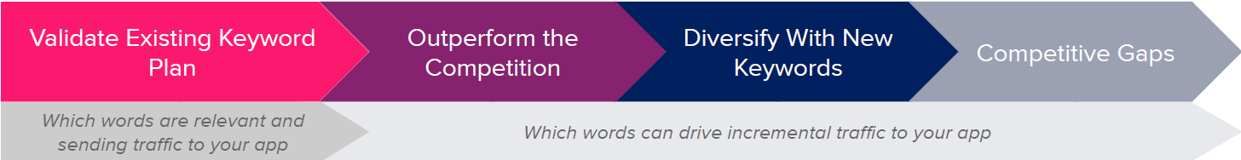



## Web-based Discovery: Top 10 keywords

Discern the top 10 keywords aligning seamlessly with the company's primary objective of retailing fashion apparel online. Execute a meticulous analysis encompassing crucial metrics for each keyword, including search volume, difficulty, keyword opportunity score, and the number of search results. This comprehensive approach ensures a strategic keyword selection that optimally supports the overarching goal of promoting and selling fashion apparel in the online domain.

1. clothing app

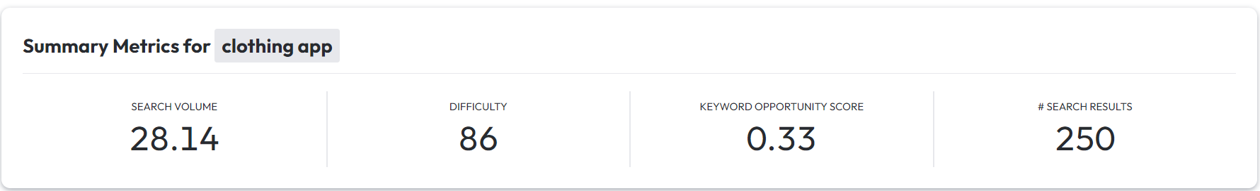

1. Fashion Trend

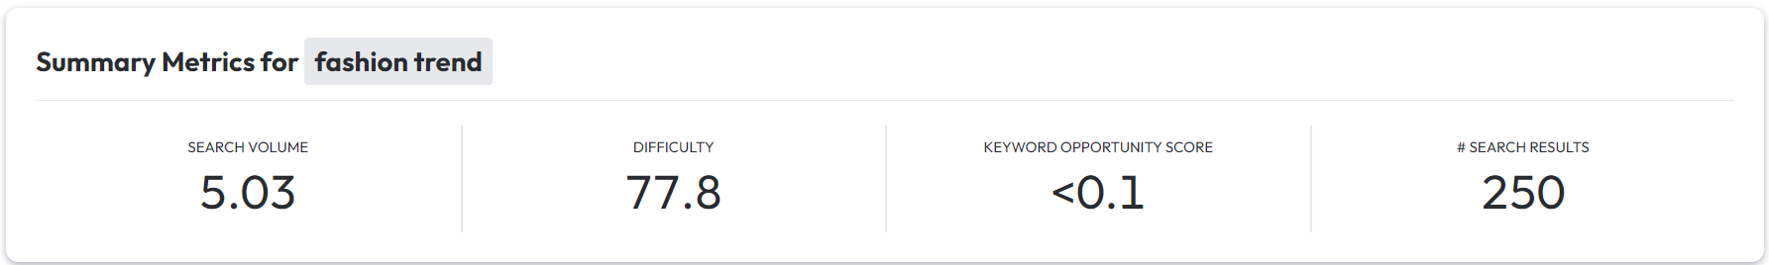

1. online shopping app

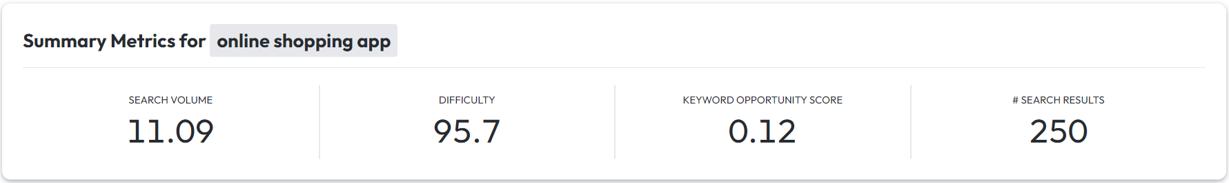

1. lifestyle app

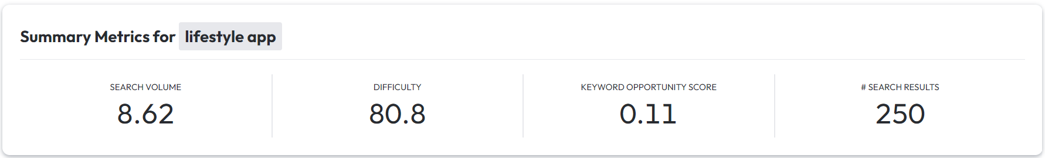

1. women’s fashion

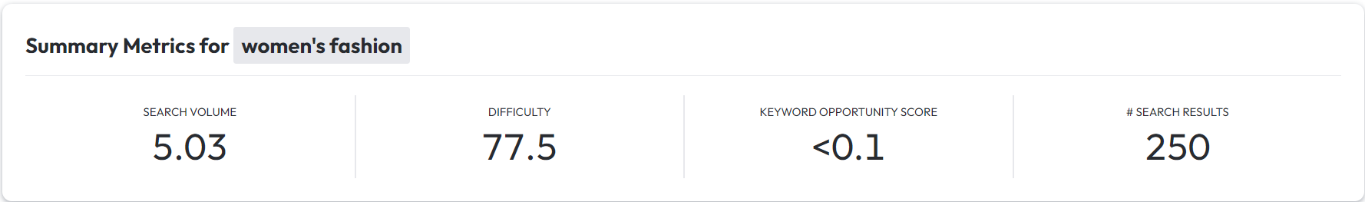

1. sportswear

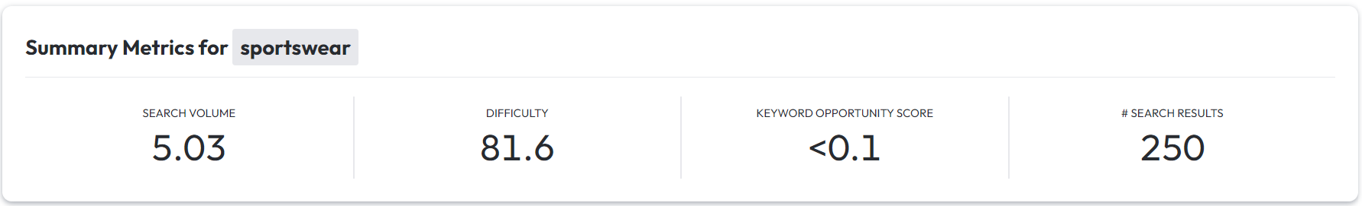

1. kids clothing

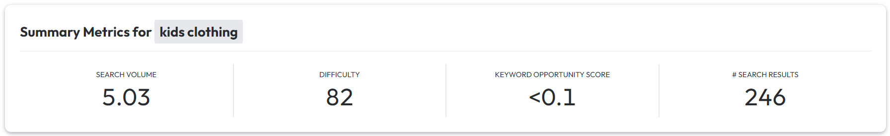

1. brands

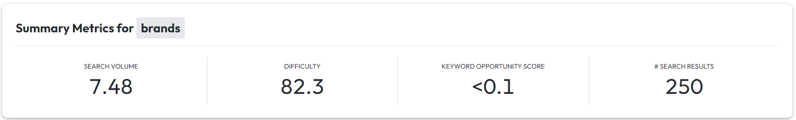

1. men's fashion

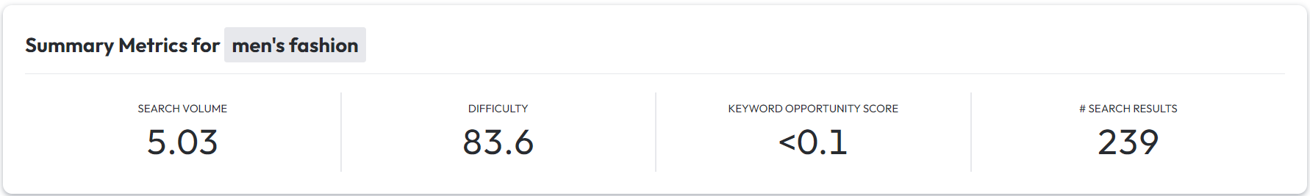

1. fashion shopping app

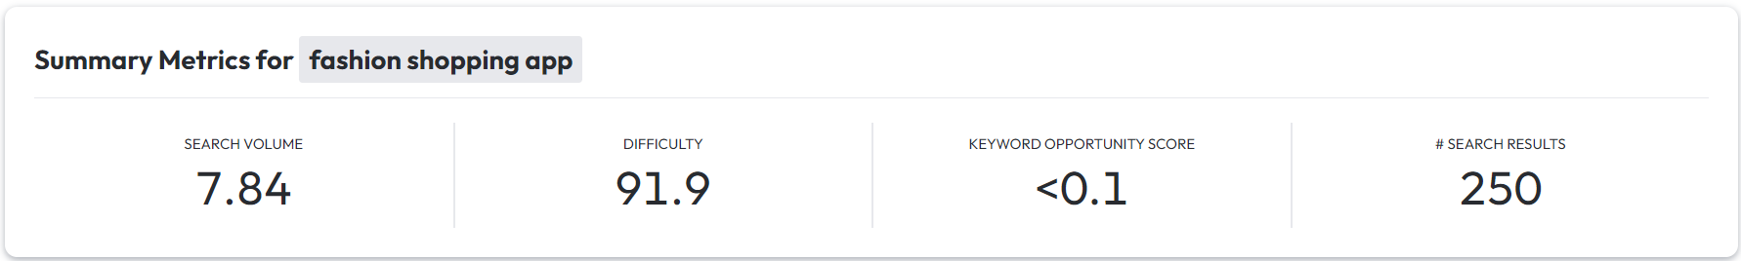

## Competitors Identified with the keyword - Fashion.

Drawing insights from the identified key competitors mentioned above, conduct a thorough analysis of how these competitors strategically employ the keyword 'Fashion' in their digital marketing efforts. The accompanying screenshot provides a concise overview of key metrics for the keyword 'fashion shopping,' including the top apps utilizing this keyword, showcased by their respective keyword ranks. This analysis serves as a valuable reference to understand the competitive landscape and refine our digital marketing strategy accordingly.

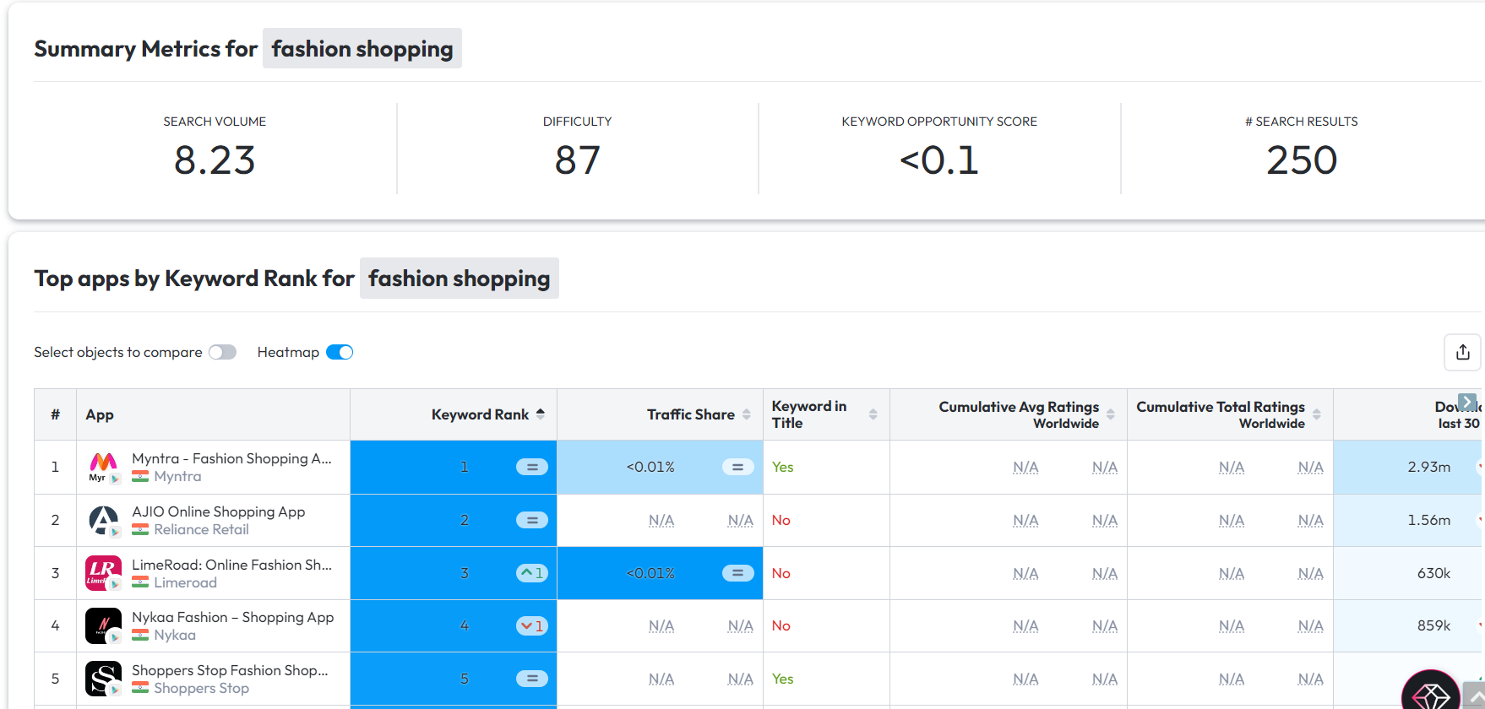

Attached is the comprehensive list of competitors that are using keyword ‘fashion shopping’ in their app either in app title, short description, or long description.

List of all competitors



Leveraging a keen understanding of our competitors, we've conducted a meticulous analysis to unveil the specific keywords employed by each contender. The following screenshots present a comprehensive view of the competitor keywords utilized by the top five contenders, providing invaluable insights to strategically position our brand in the competitive landscape.

Top Keywords that competitors using are:

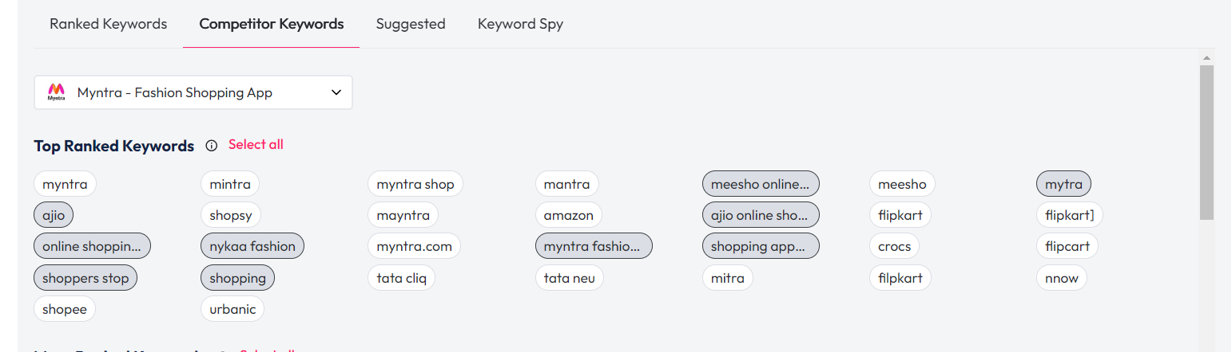

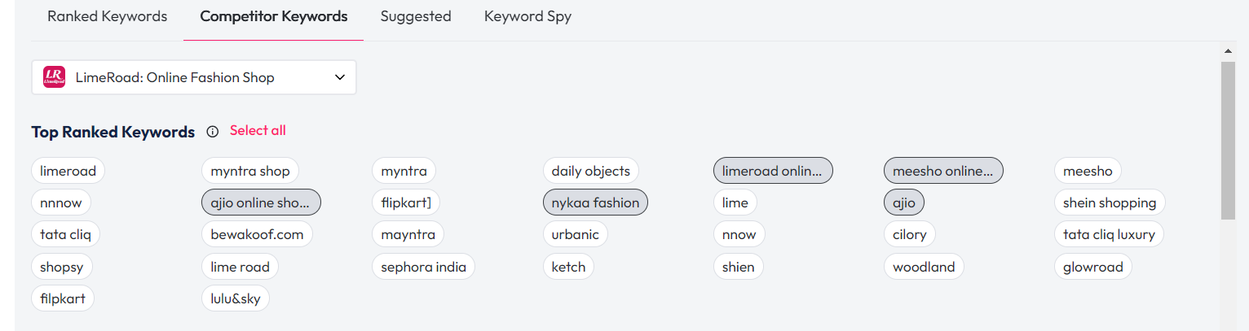

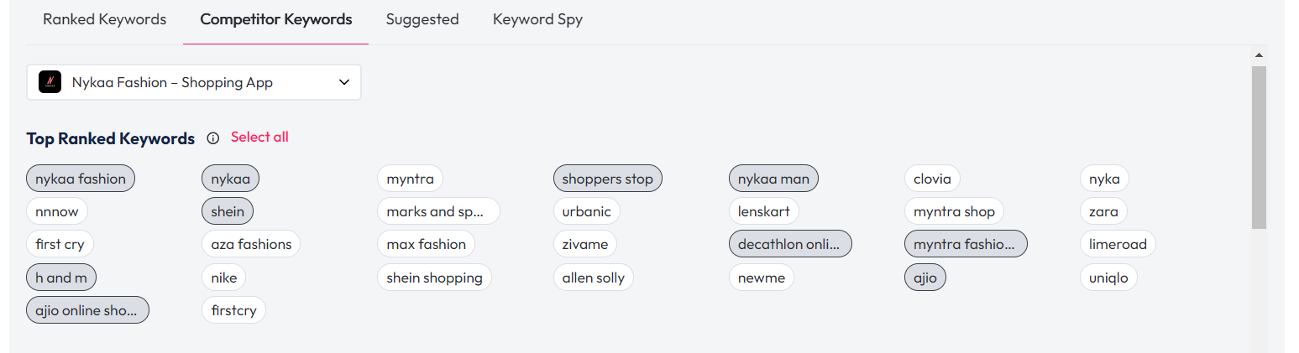

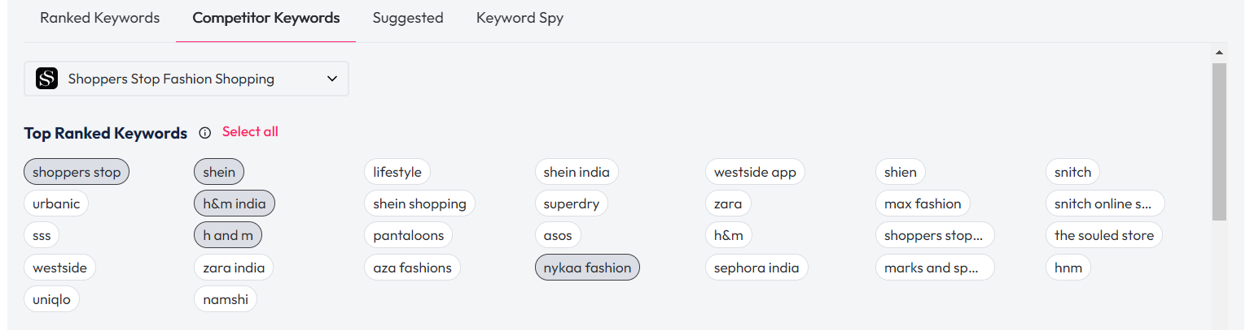

Added the above identified top-10 trending keywords and feed these keywords as seed keywords to get more suggested keywords that could possibly help in improving the ASO ranking:

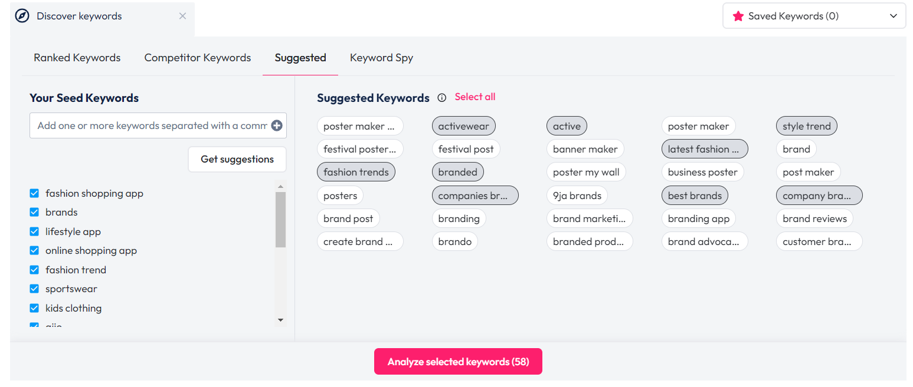

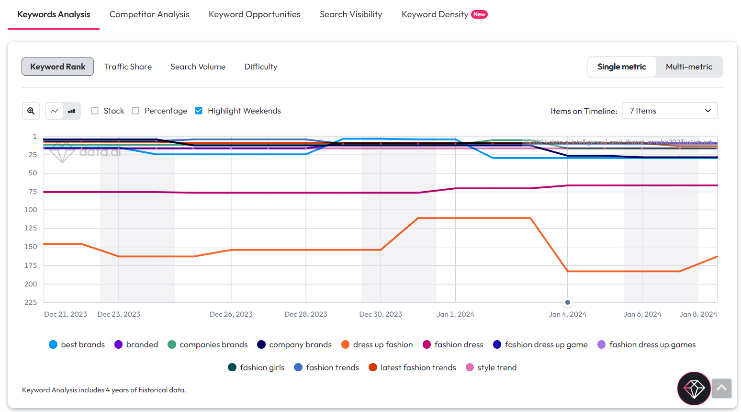

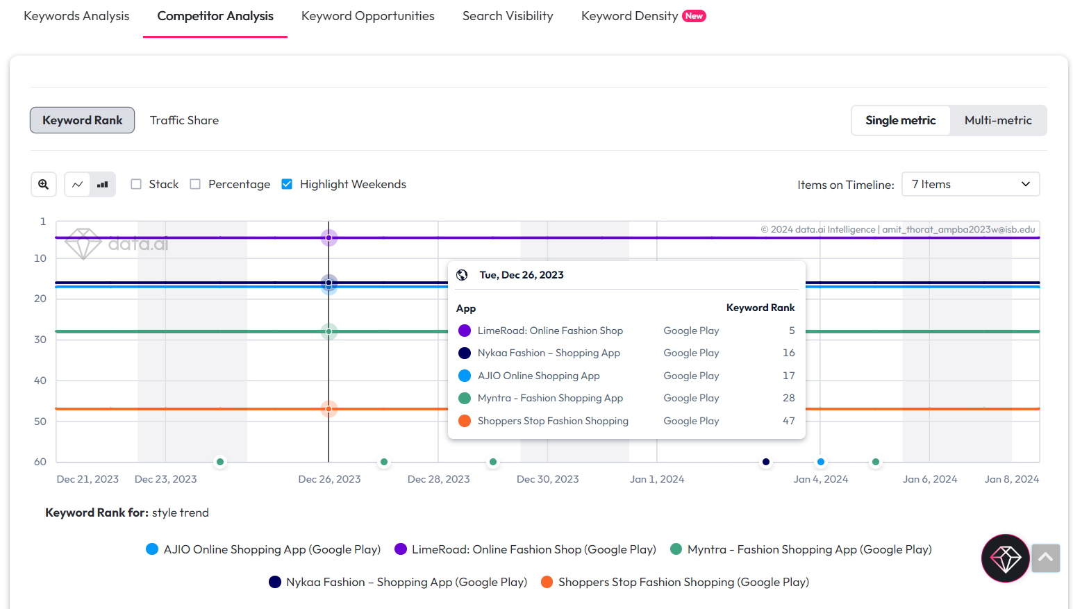

Magic quadrant analysis of selected 27 words based on ASO categories – Opportunities, Popular But Difficult, Niche Keywords, & Avoid.

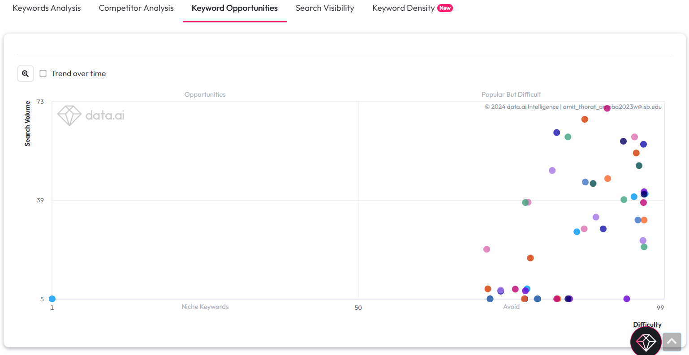

Almost all the words are lied in the two categories of ‘Popular But Difficult’ & ‘Avoid’. This means that lot of words may not yield the desired results however, the keywords that are falling the ‘Popular But Difficult’ quadrant can be use.

In addition to these keywords, I have did paid keyword analysis details can be found in below section 3.5

List of keywords:





Note: Above analysis includes the default Ajio’s keywords + top 10 keywords that are identified from the SEMrush & neilpatel keyword planner sites.

## Competitors Timeline Monitoring

Conduct a detailed analysis of each competitor, delving into the frequency and consistency of updates made to their respective apps. This examination aims to discern the strategic approach and responsiveness of competitors in adapting to evolving market dynamics, offering valuable insights for our own strategic planning.

**Myntra**

The following screenshots present a chronological timeline view of Myntra's app updates. Upon thorough analysis, it is evident that Myntra consistently refreshes its app description and screenshots. This proactive approach is strategically designed to captivate a broader audience, showcasing seasonal updates and ultimately boosting traffic to the platform.

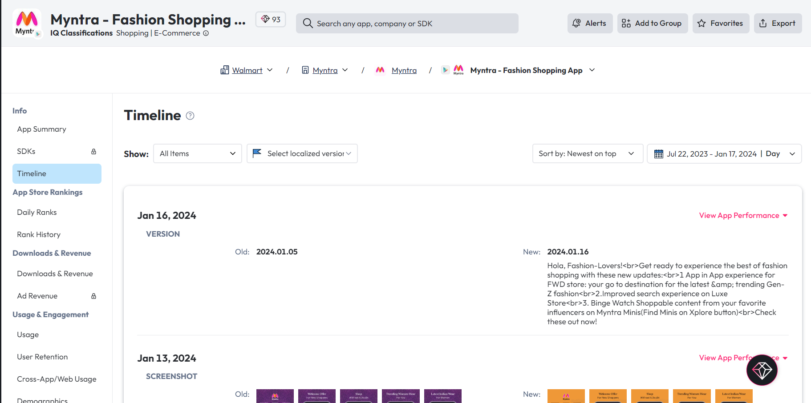

**Ajio**

The accompanying screenshots unveil a comprehensive timeline view of Ajio's app updates. A meticulous analysis reveals that Ajio consistently enhances its app version and refines screenshots as part of a dynamic strategy to allure customers. Through compelling imagery, the app effectively communicates new offers, contributing to an increased flow of traffic and heightened engagement.

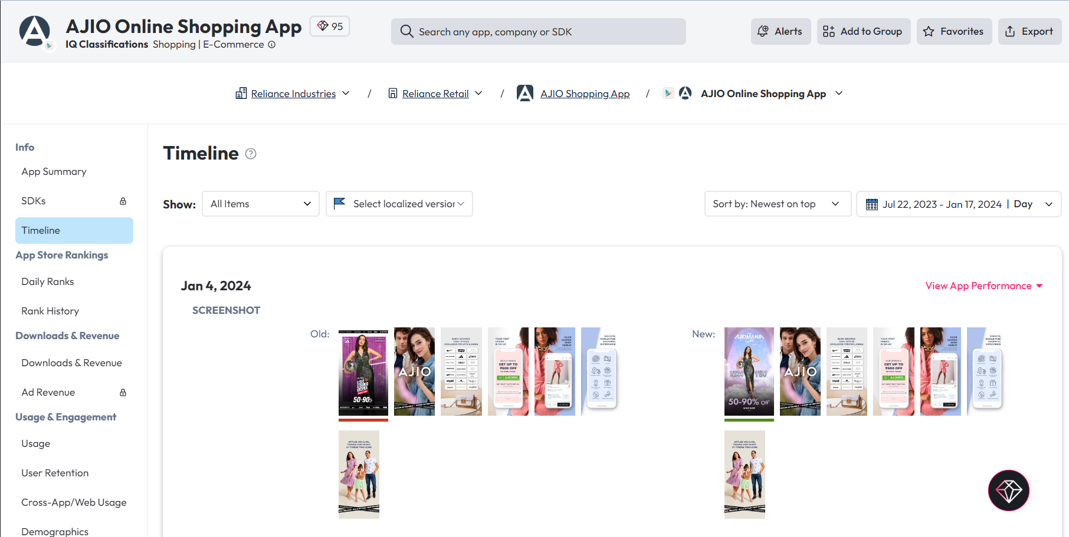

**LimeRoad**

The provided screenshots offer a chronological perspective on LimeRoad's app updates. Upon careful examination, it is notable that the app experiences relatively infrequent updates, primarily limited to version enhancements. This pattern has, unfortunately, translated into subdued traffic on the app, highlighting the potential impact of a more dynamic update strategy on user engagement and traffic generation.

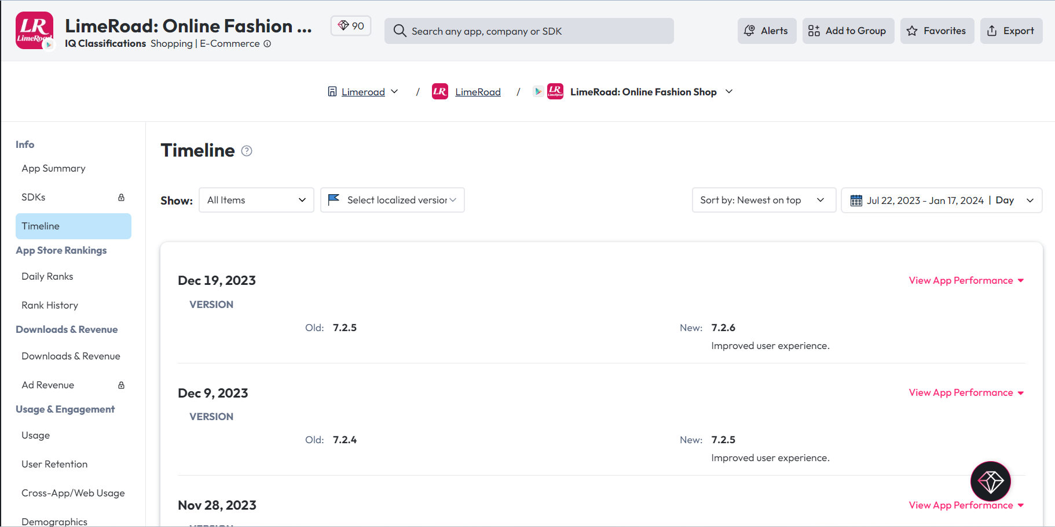

**Nykaa Fashion**

The accompanying screenshots provide a detailed timeline view of Nykaa Fashion's app updates. A comprehensive analysis reveals a monthly cadence in updating both the app version and description as part of a concerted effort to engage customers. It is noteworthy, however, that the current description might not be as compelling as desired, suggesting an opportunity for refinement to further captivate the audience and drive sustained interest.

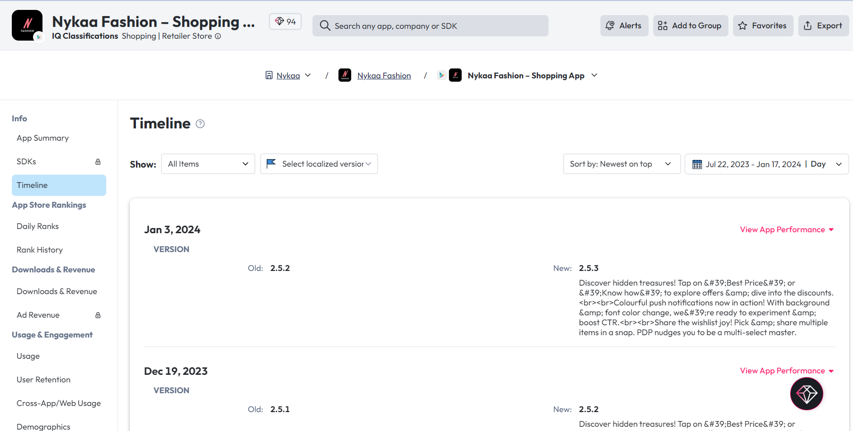

**Shoppers Stop**

The enclosed screenshots present a chronological overview of Shoppers Stop's app updates. Upon meticulous examination, it becomes apparent that the app experiences irregular updates, with the primary focus being on version enhancements. This pattern underscores an opportunity for more regular and diverse updates to optimize user experience and engagement on the app.

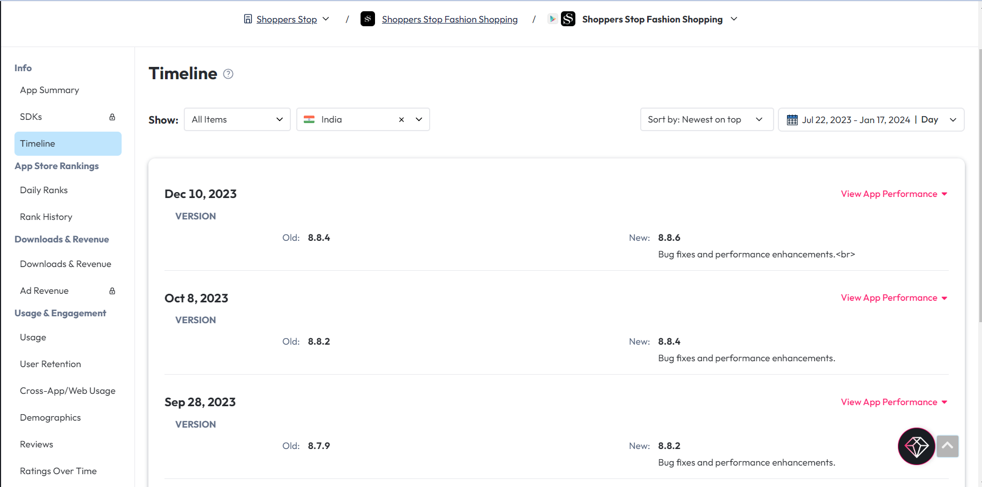

## Competitors progress Monitoring and Updates

To perpetually track and assess competitor performance, a dynamic dashboard has been meticulously developed. The following screenshots vividly illustrate the ongoing progression and evolution of this monitoring system.

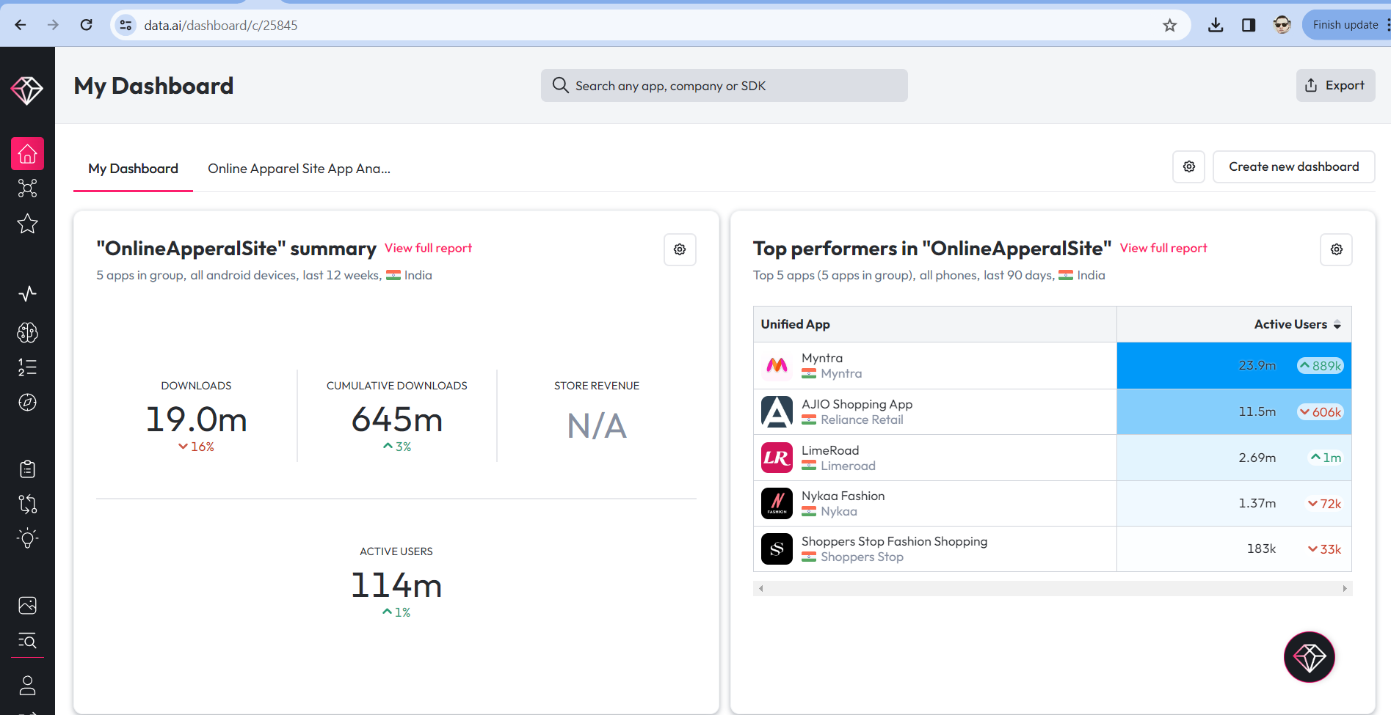

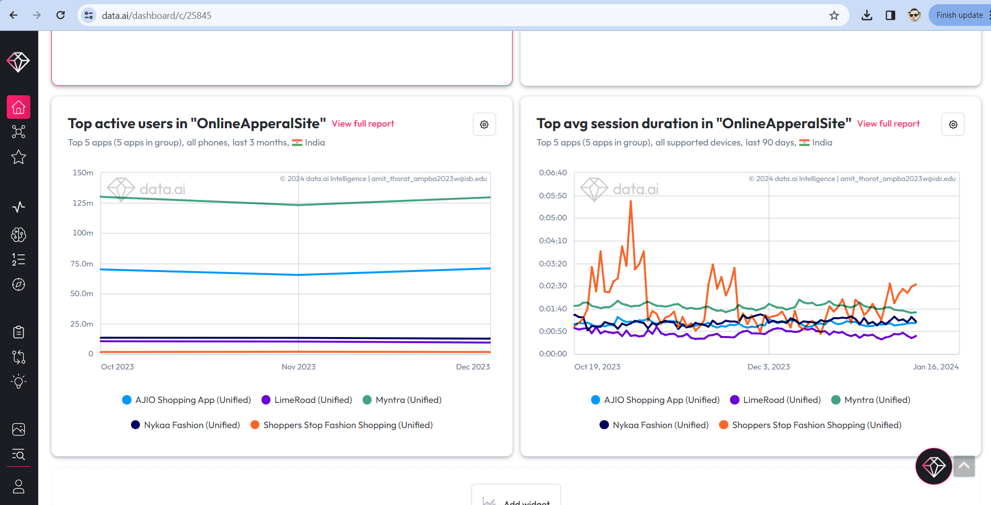

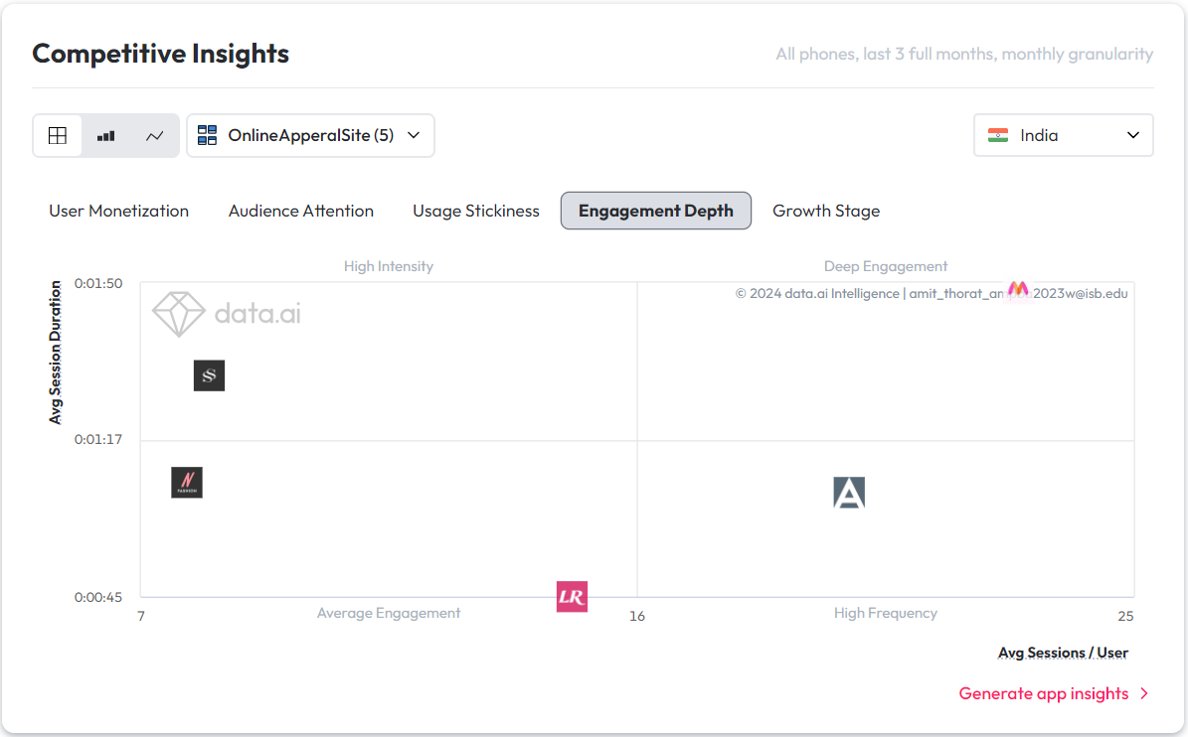

Upon the TrendTrails app's launch and availability for download on the Play Store, the dashboard will be enriched with new widgets. Stay abreast of developments by configuring setup alerts with a myriad of metrics, facilitating vigilant monitoring of competitors' performance. This proactive approach ensures real-time insights into the competitive landscape.

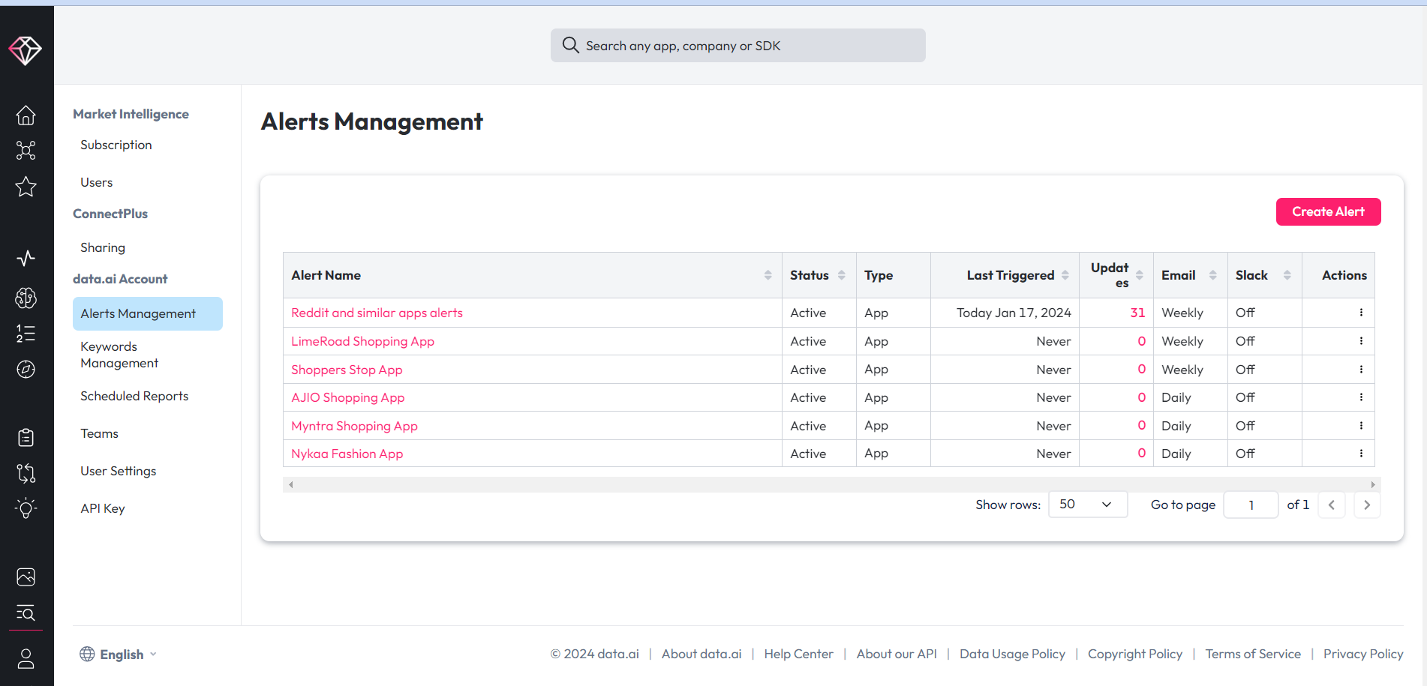

## Competitors Paid Keyword Search Analysis

Conducting an in-depth analysis of each competitor involves pinpointing the specific keywords they target. Once identified, a strategic plan can be devised for the utilization of these keywords, potentially enhancing traffic. While this approach may entail an increased digital marketing budget, its effectiveness lies in its capacity to bolster market share and outmaneuver competitors, making it a valuable investment for sustained growth.z

**Myntra**

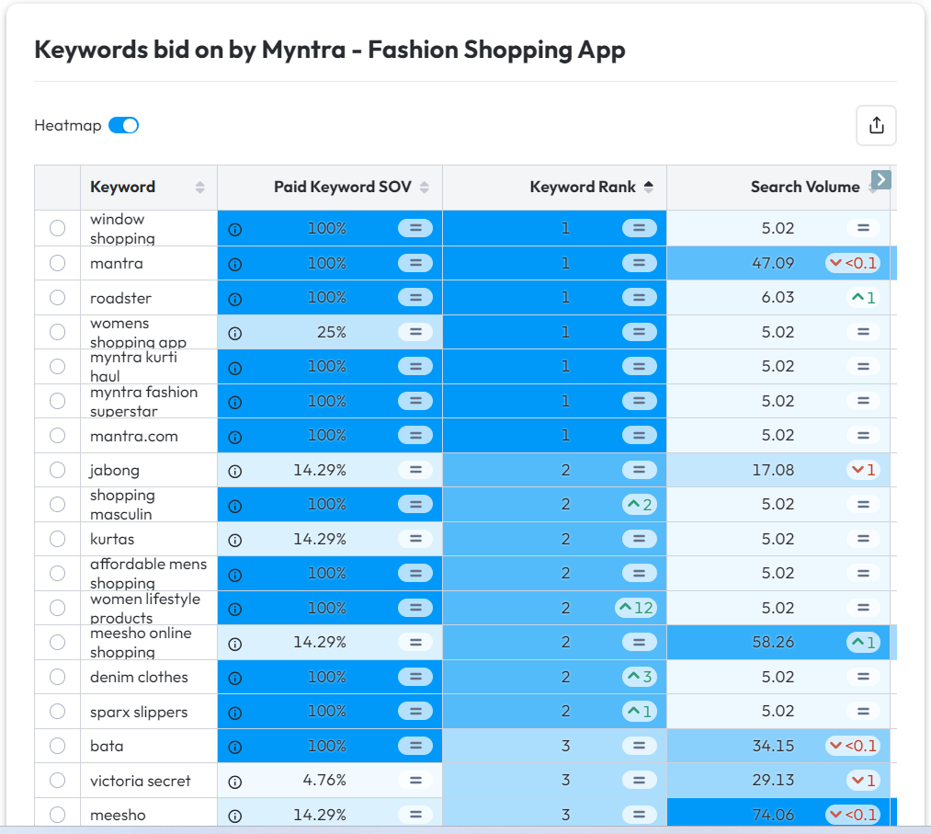

**Ajio**

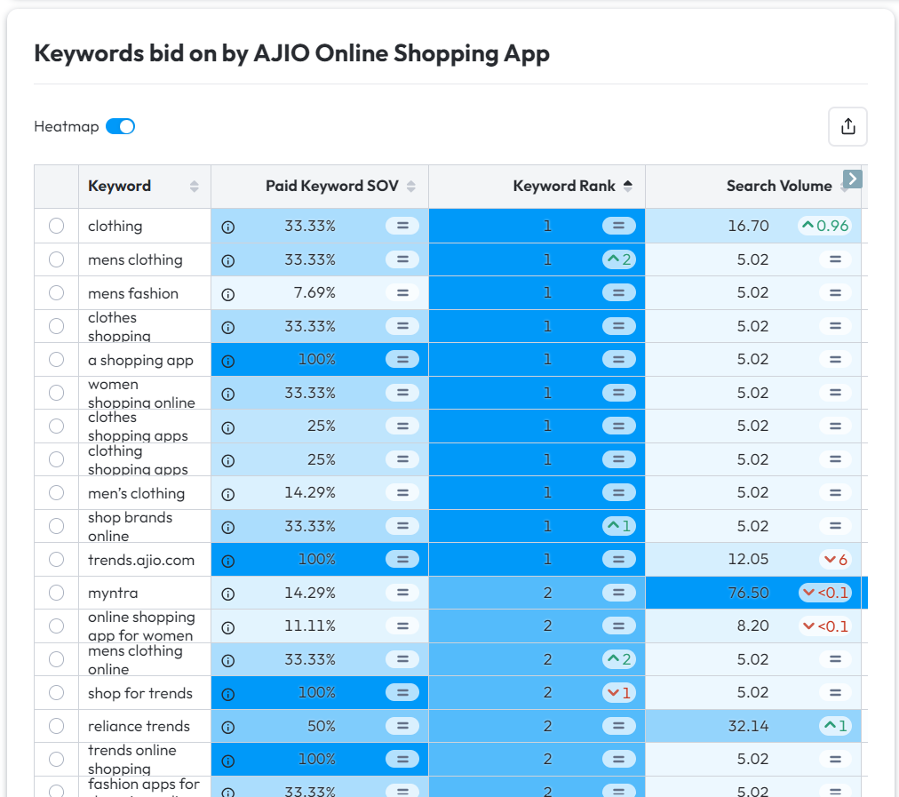

**Nykaa Fashion**

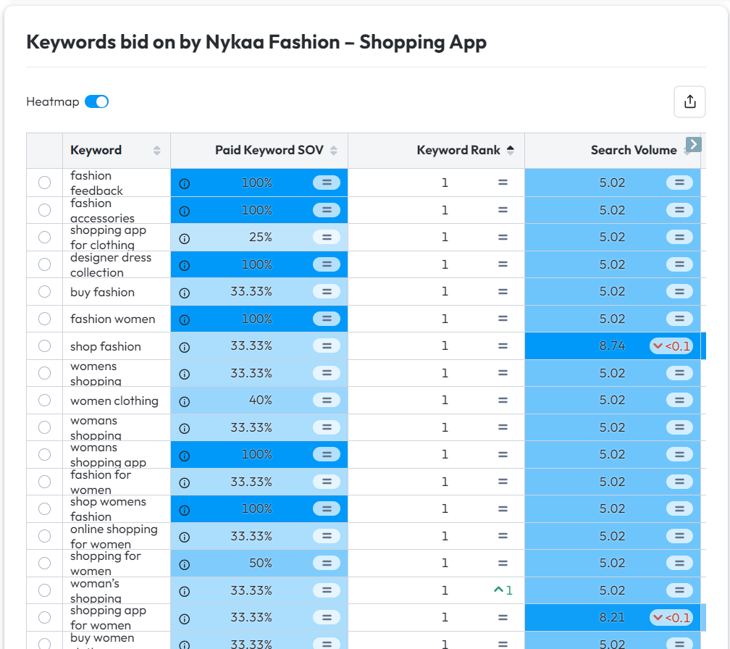

**LimeRoad**

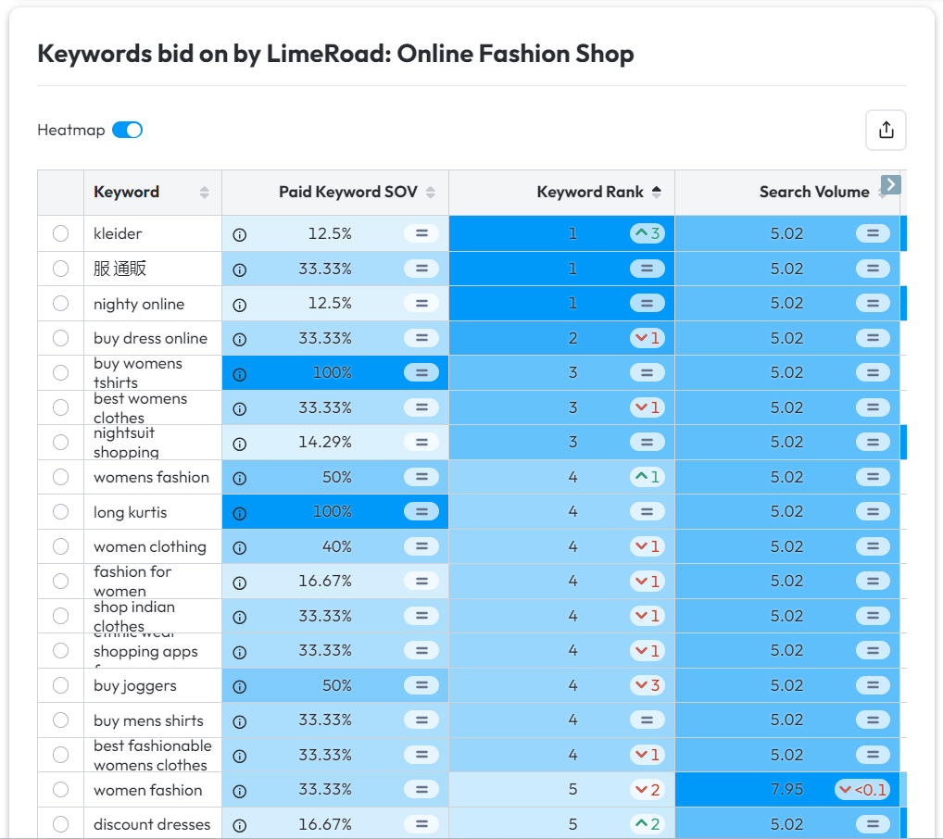

**Shoppers Stop**

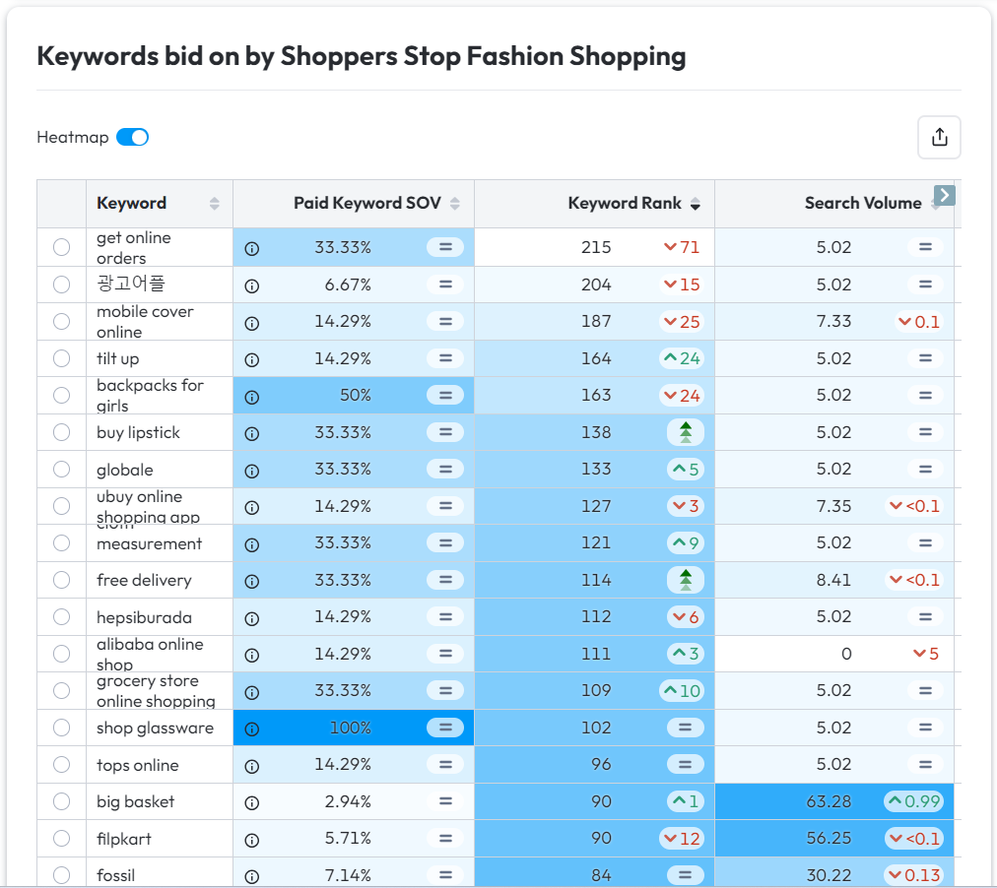

To scrutinize the realm of paid keyword searches and strategically allocate TrendTrails' digital marketing budget, I crafted a Python code. This code meticulously analyzes the keywords that competitors are actively bidding on, pinpointing common ground. By leveraging this insight, TrendTrails can optimize its spending by strategically focusing on shared keywords rather than investing across the entire spectrum targeted by competitors. Presented below is a snippet of the Python code and its corresponding output.

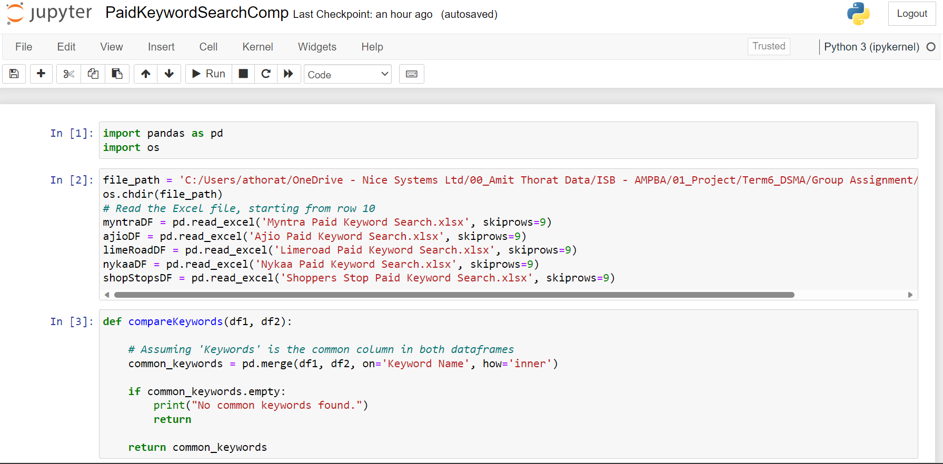

Common keyword output screenshot



Attaching the ipynb file for the further analysis and common keywords output extracted from the comparison analysis.

Paid keyword search comparison program.



Common Paid Keyword Search



## ASO Based App Recommendation

Considering the ASO framework and assessment model outlined above, incorporating the top 10 keywords and additional keywords derived from competitors' paid search strategies, I propose the following enhancements to the App Name, App Logo, App Short Description, and App Long Description as detailed below.

**App Name**:

TrendTrails - Shop Top Brands & Looks Fashion App

**App Logo**:



**App Short Description**:

Discover endless fashion styles. Shop top brands with up to 80% off. Free fast delivery and returns. Pay easily & securely.

**App Long Description**:

Discover Your Style with TrendTrails - Shop Top Brands & Looks Fashion App

Explore endless fashion inspiration with TrendTrails, the premiere lifestyle and shopping app for clothing, accessories, beauty, and more. Find stunning looks for every occasion curated just for you by our team of fashion experts.

TrendTrails offers:

💄 Women's Fashion - Flaunt the season's latest designer trends from dresses, jeans, tops and jackets to shoes, handbags, jewellery and other must-have accessories. Shop thousands of options from premium brands like Forever21, Vero Moda, Only, AND, Global Desi, and our own exclusive private label.

👔 Men's Fashion - Upgrade your wardrobe with stylish shirts, t-shirts, trousers, sportswear and formal suits from top brands like Spykar, LP, U.S. Polo Assn. and more.

👟 Sportswear - Shop activewear including shoes, apparel and gear from Nike, Puma, Adidas, Reebok, Skechers, Fila, and other leading sportstyle brands.

👗 Kids Clothing - Dress your little ones in comfortable, fashionable clothes from popular kidswear brands like Max Kids, YK, and Hopscotch.

🛍 Designer Brands - Find premium Indian designer clothing, jewellery, bags and shoes from coveted names like Ritu Kumar, Masaba, Satya Paul, Shivan & Narresh, JJ Valaya and more.

Perks of TrendTrails:

* New sales every day with savings up to 90% off
* Free and fast delivery
* 15 day free returns
* Pay securely via card, UPI or cash
* 24x7 support

Elevate your style anytime, anywhere with TrendTrails!

Download now and use code "NEWTTRAILS" to get 20% off your first order.